**GIT**

Git is a distributed version control and source code management system.it is used to track the changes of source code during the software development. And it was built on c language.

* Other types of version control systems are Subversion and mercurial

**Git architecture**

Working directory 🡪 Staging area 🡪 Local/Central Repository.

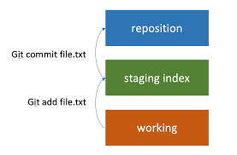

**Working directory:**

The folder/ directory in local machine where we work to make changes in code.

**Staging area:**

Staging area is also called as index, it sits between the working directory and Repository. It works as a preparation area where changes are gathered and organized before committed to the repository. Staging is nothing but a preparation of the snapshot of the changes that need to commit.

**Repository :**

A central place where data is stored and managed. If data is stored locally then it is local repo or it data is hosted in internet then it is Remote repository.

**Git installation and configuration.**

* Git was a software and built on C language so we need to install it in machine using 🡪 *sudo apt install git*

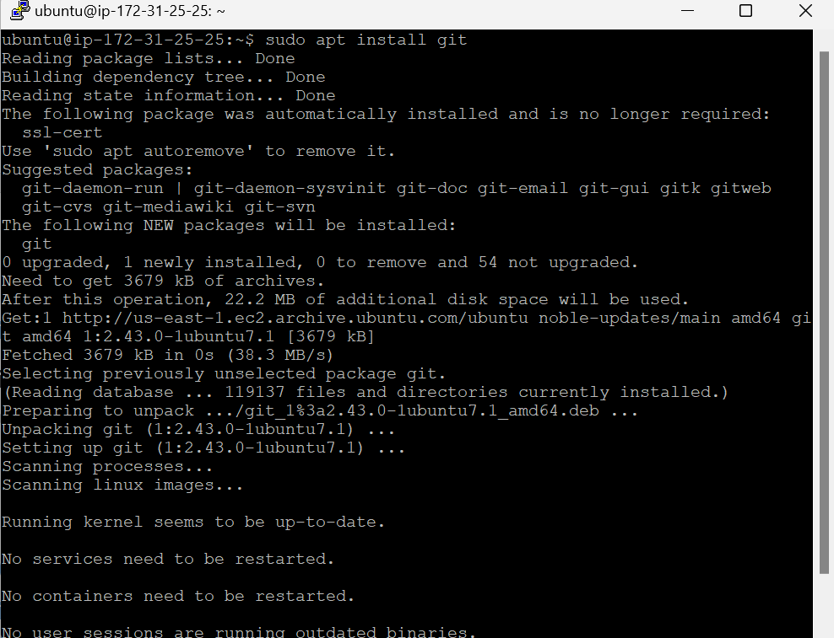

Check the version of the git using 🡪 *git –version*

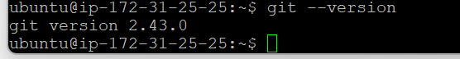

Configuring username and email id and checking for the same

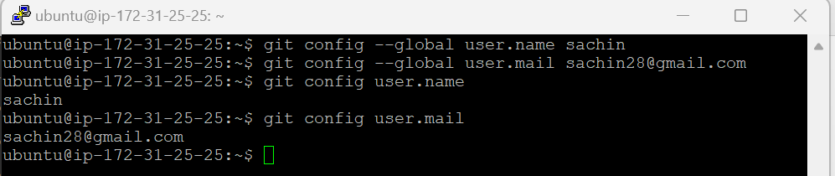

**Connect to the github:**

Add ssh key to git hu and connect our instance to github using command [git@github.com:email28/OPQ.git](mailto:git@github.com:email28/OPQ.git) and check the connection as shown below.

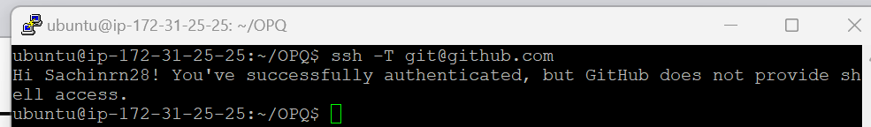

**Typical Git commands:**

* Initialize git –> *git init*

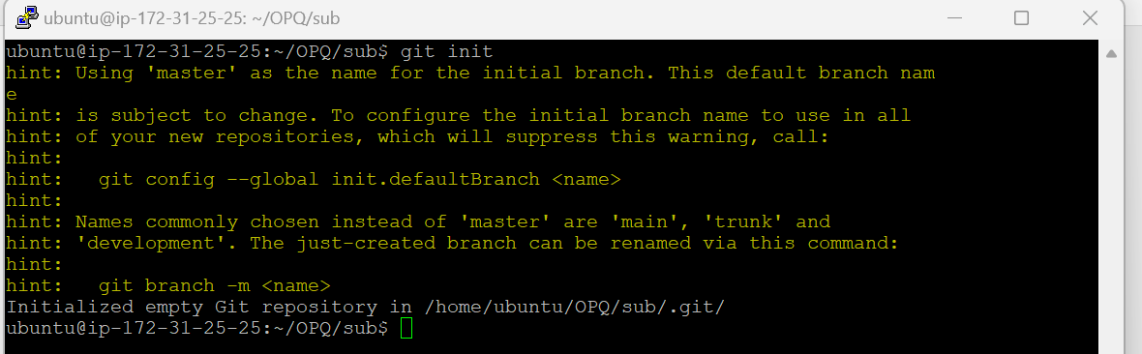

Creat a copy of the main repository to the local repository 🡪 git clone [git@github.com:email28/OPQ.git](mailto:git@github.com:email28/OPQ.git)

* Create add and commit file.

1. To creat file -- > *touch test_file*
2. To add file to staging area 🡪 *git add test_file*
3. To commit file 🡪 *git commit test_file*

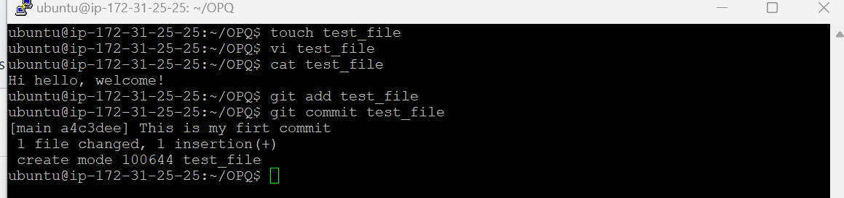

*Note these changes are in my working directory.

* To bring the changes in remote repo 🡪 *git push*

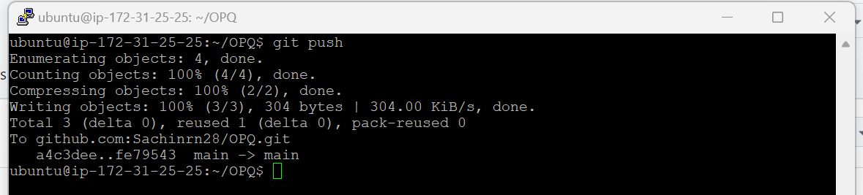

* To fetch and integrate changes from a remote repository to local machine 🡪 *git pull*

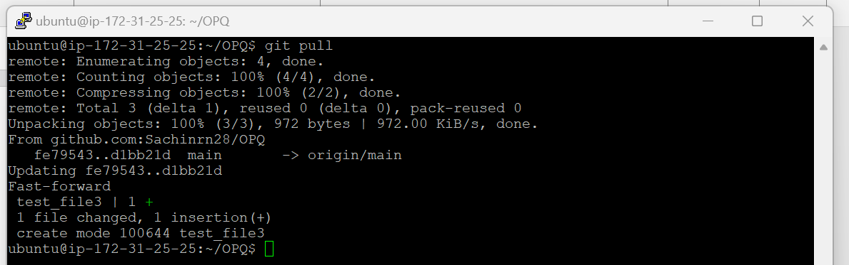

* To check the status of the files in working directory 🡪 *git status*
* 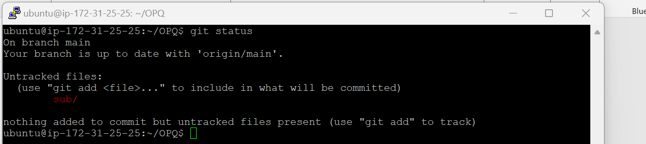
* To check the difference between the files in local and remote repo file 🡪 *git diff*

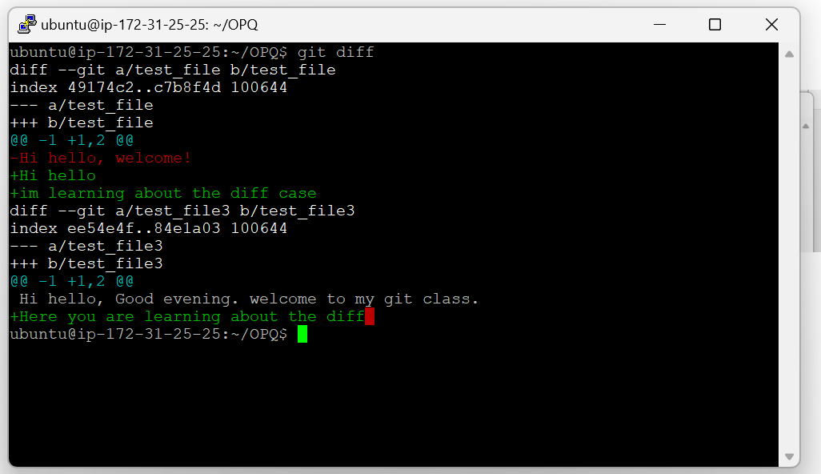

To check the difference between the staging area files and last commit of the same file – *git diff –staged*

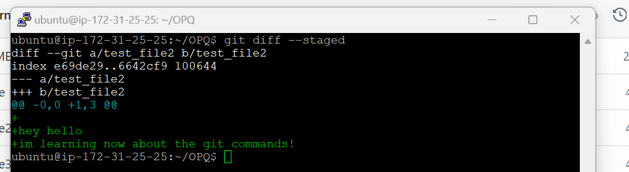

To check the commit log (which shows the commit history) 🡪 *git log*

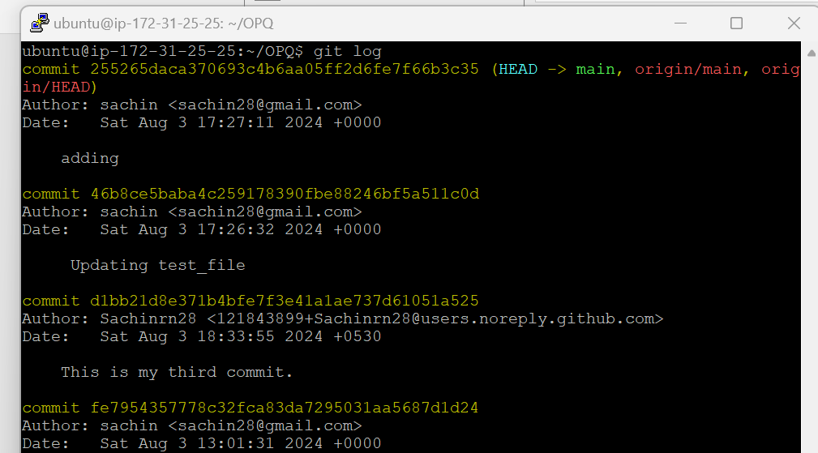

To check the log in one line 🡪 *git log –oneline*

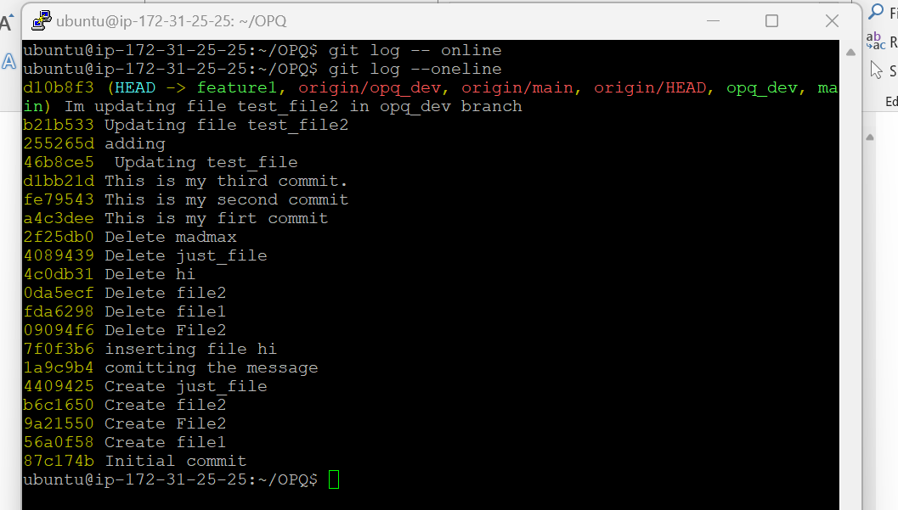

To check the log in tree form 🡪 *git log –graph*

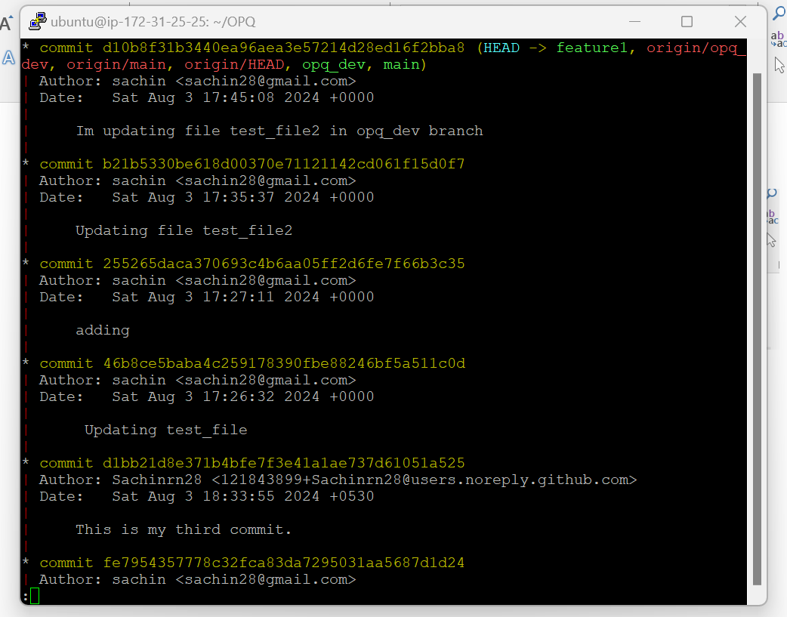

To add message to the commit 🡪 *git commit -m “about the commit we are bringing”*

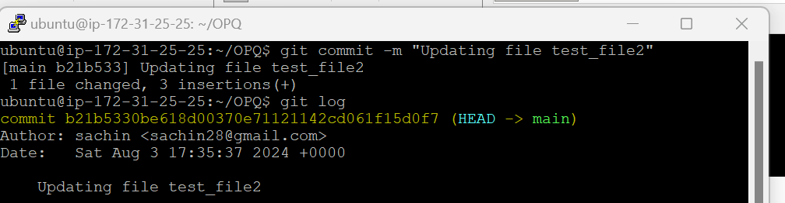

To create branch in the repo 🡪 *git branch branch_name*

To list all branch created 🡪 *git branch*

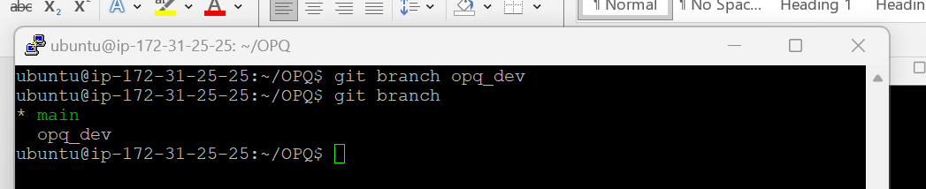

To check out from that branch 🡪 *git checkout branch name*(to where we need to move)

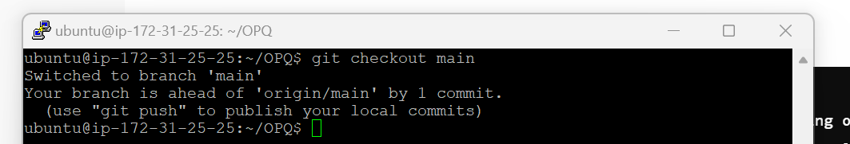

To merge the files form the different branch 🡪 *git merge branch name*, This will create new commit id.

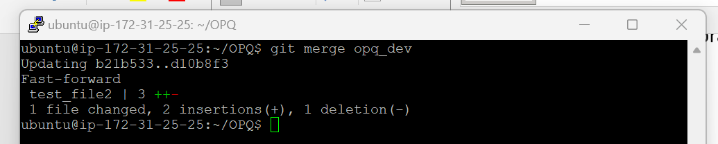

To push the branch created in our working repo 🡪 *git push -u origin branchname*

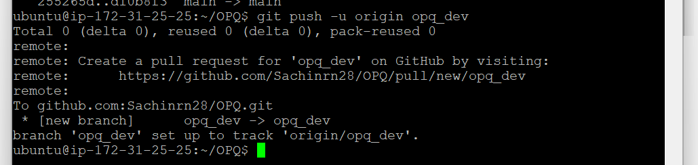

To check the list of branches available in remote 🡪 *git branch -r*

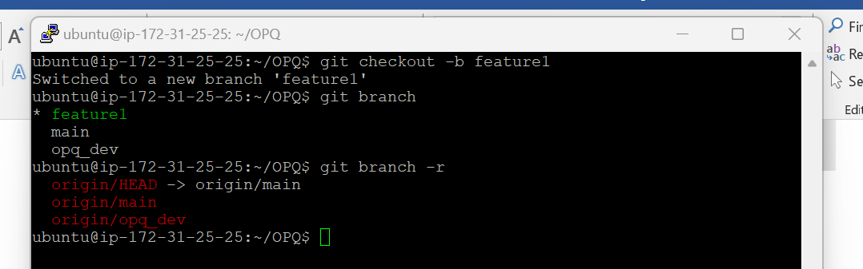

To check out from current branch and create new branch 🡪 *git checkout -b new _branch_name*

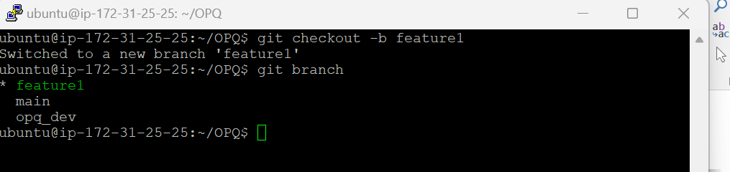

To delete the branch 🡪 *git branch -d branch name*

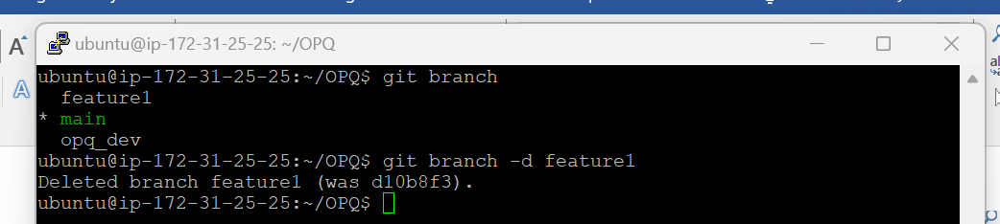

To create central repo 🡪 *git init –bare*

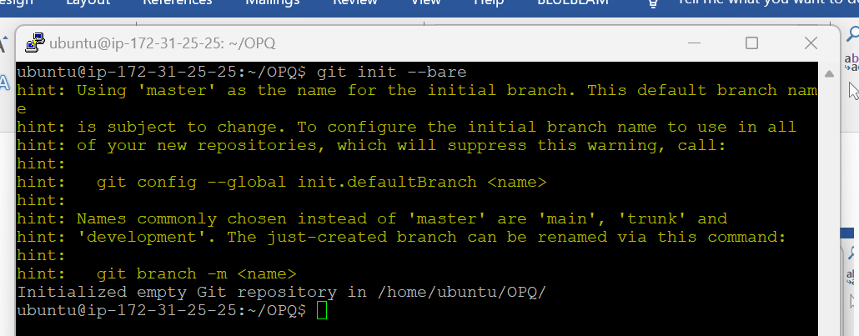

To remove file from the staging area and from the list 🡪 *git rm*

* This will remove file even if it is in staging area

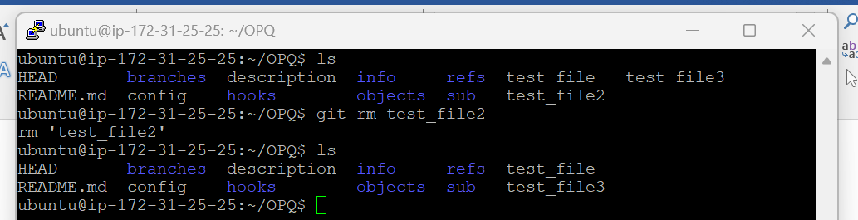

To clean up the repo 🡪 *git gc*

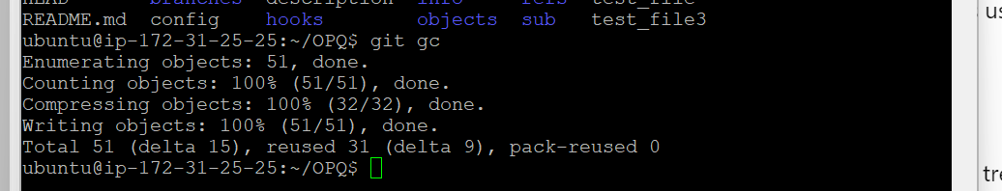

To check the detailed information about the particular commit 🡪 *git show commit id*

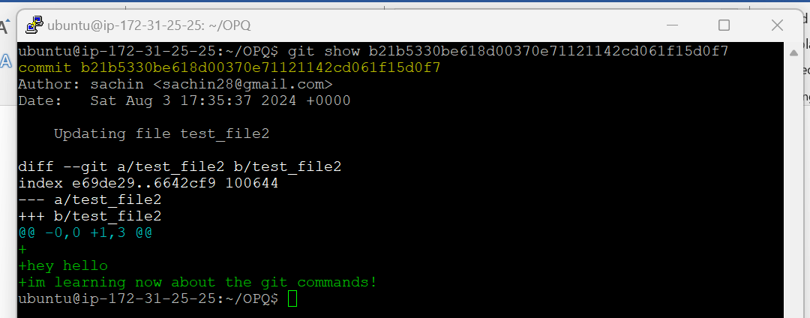

To change the commit message 🡪 *git commit –amend* … this will open a text editor we can change there

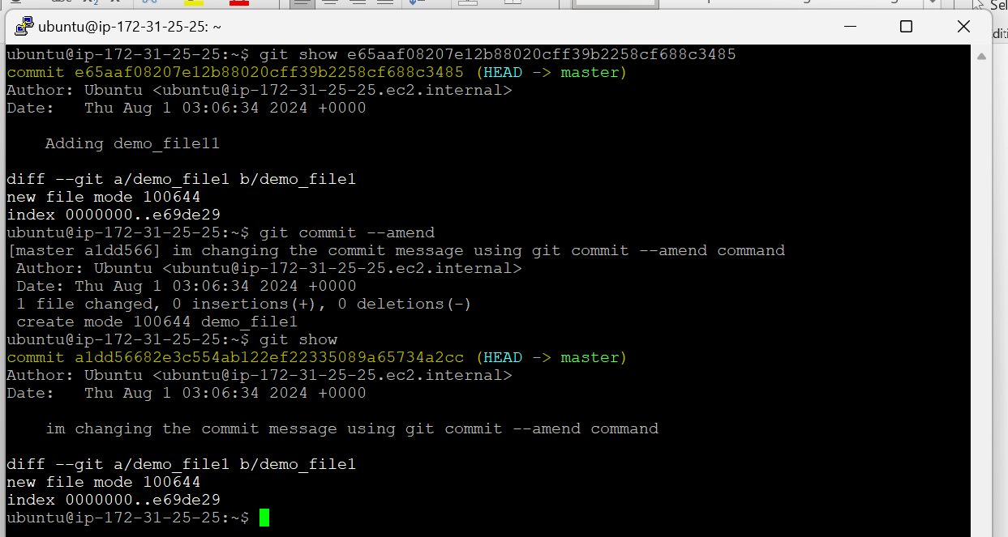

To navigate between the branch 🡪 *git switch branch*

This command used to switch between the branchs

To check the connectivity between the github repo 🡪 *ssh -T git@github.com*

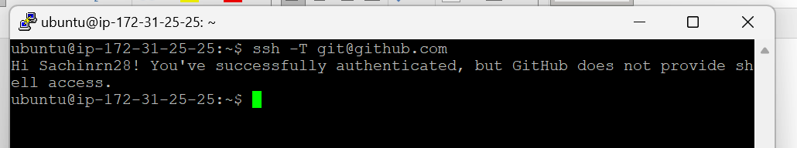

Git blame is command used to check who did what change *–git blame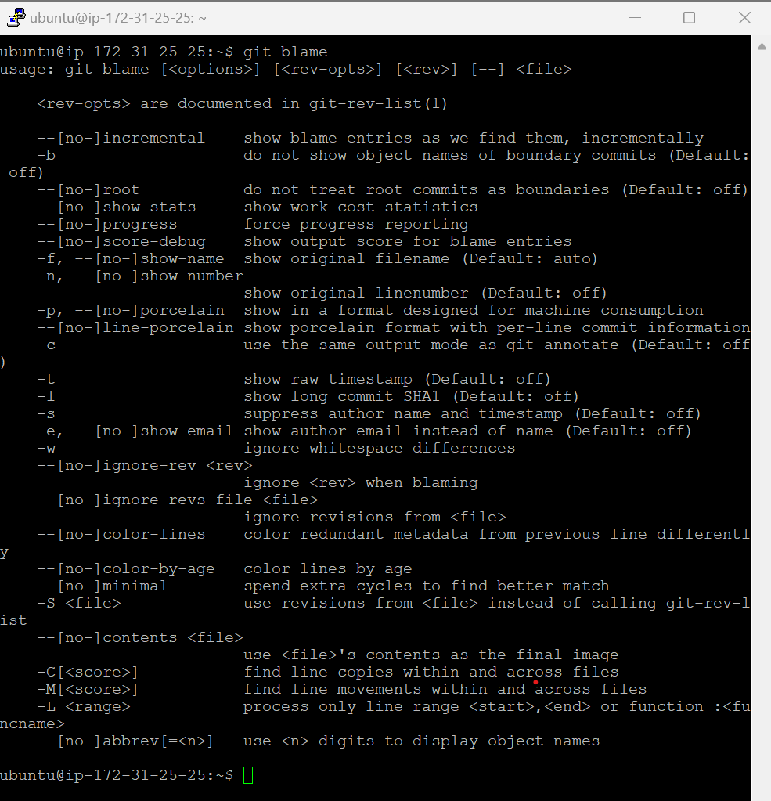*

**Git revert**

Git revert also will take one commit back but it will create new commit id

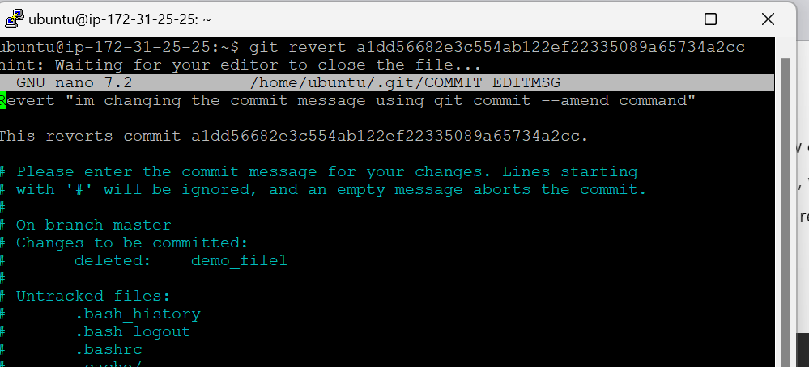

**Maven, Tomcat**

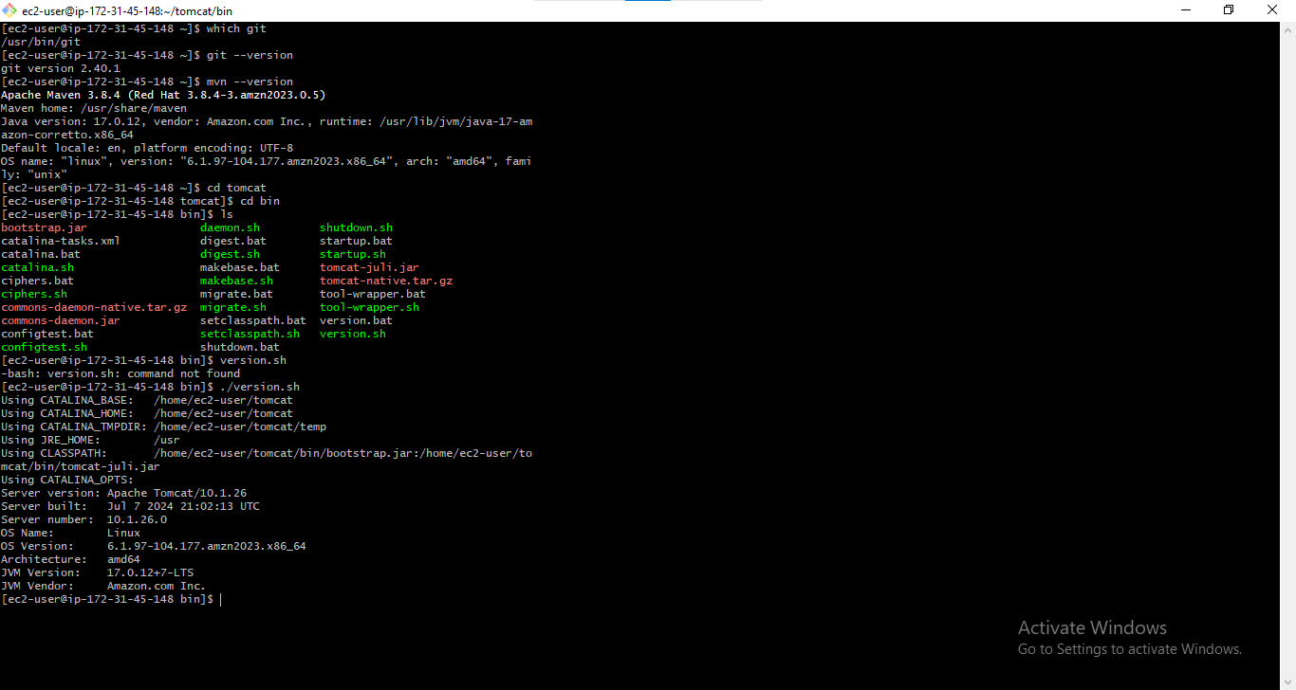

**Enable tomcat**

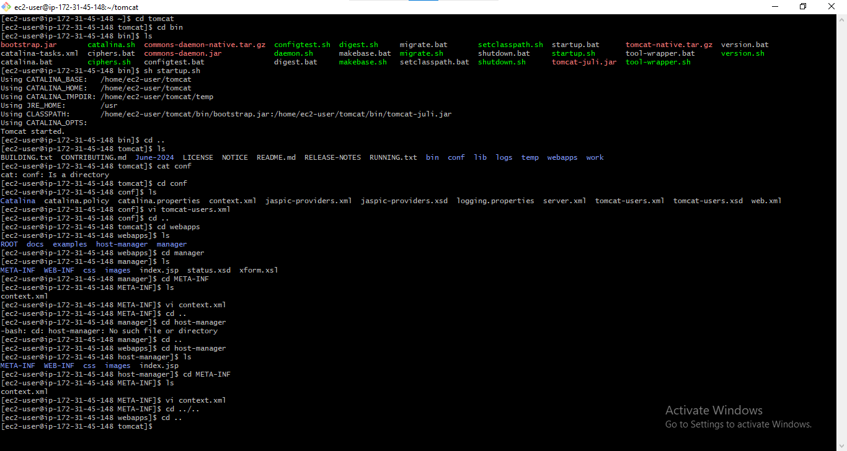

Manager

Cd/webapps/manager/META-INF

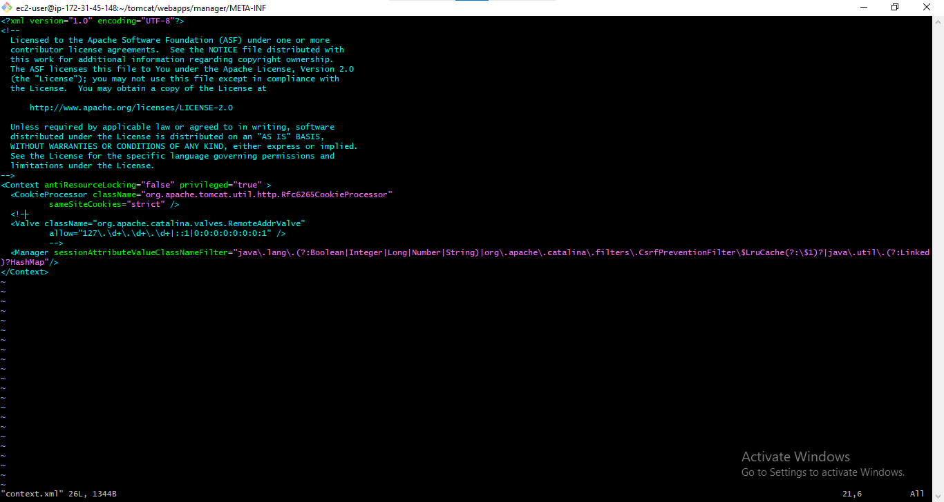

Host Manager

Cd/webapps/host-manager/META-INF

